ICOMOS SCHOLARSHIP RESEARCH
Heritage Protection Legislation National and International

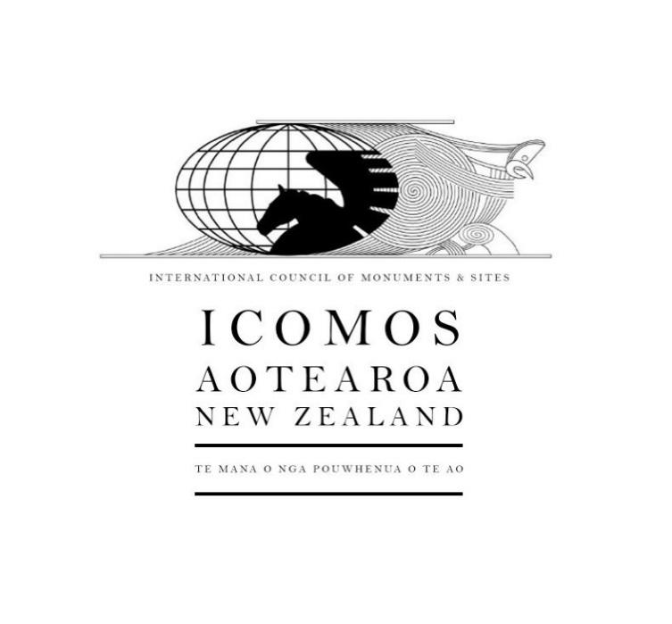
FINAL REPORT

Author: Sita Dahal
Submitted: April 2026
Research Period: 12 January 2025 – 31 March 2026

Prepared for: ICOMOS New Zealand

Executive Summary
This report evaluates the major pieces of legislation affecting heritage protection in Aotearoa New Zealand that have been introduced between 2020 and 2025, highlighting a systemic shift toward prioritizing development speed and property rights over cultural conservation. Through a comparative analysis of jurisdictions in Australia, Ireland, the United Kingdom, and Canada, the research demonstrates that New Zealand’s current trajectory, marked by the Fast Track Approvals Act 2024 and proposed Resource Management Act reforms, diverges from international best practices. While comparable unitary systems like Ireland and England successfully integrate heritage protection with housing supply through independent merit reviews and robust statutory oversight, New Zealand's framework is becoming increasingly fragmented and vulnerable to political overrides. Although current and proposed settings prioritize development speed, the research suggests that stronger national direction, mandatory consideration in both planning and natural environment frameworks, independent judicial accountability, and improved multi-agency coordination would better safeguard irreplaceable cultural heritage values. Consequently, the findings recommend the establishment of a National Heritage Monitoring System to provide evidence-based data for future policy making.

1. Mapping Significant Legislative and Policy Reform in Aotearoa New Zealand

1.1. Review of the Last <5 Years of Legislative Change
Major pieces of legislation affecting heritage that have been introduced in the last 5 years (2020-2025) are summarized in the attached spreadsheet, along with relevant case law.
The current coalition government was formed at the end of 2023. Following their election, they repealed the Natural and Built Environment Act 2023 and the Spatial Planning Act 2023 that had been introduced by the previous government to replace the Resource Management Act (RMA) 1991. Following this, they have introduced several changes affecting built heritage:
- Passed the Fast Track Approvals Act 2024 - enabling projects to bypass normal heritage consenting
- Removed heritage protection for Gordon Wilson Flats (RM Amendment Act 2025) - first time a specific heritage building's protection was removed by legislation
- Made Medium Density Residential Standards optional for councils (2024) - gives councils more discretion but removes national consistency
- Extended earthquake-prone building deadlines (2024) - provides more time but doesn't address underlying financial burden
At the time of writing this report, there are two notable legislative reforms impacting on heritage protection that are at Select Committee stage:
- Resource Management Act Reform – proposal to replace the current RMA 1991 with the Planning Act and National Environment Act, which will result in weakened provisions for the protection of heritage and requirements for compensation on the basis that heritage protection “limits” development options.
- Building (Earthquake-prone Buildings Amendment) Bill 2025 – proposal to change the way that earthquake-prone buildings are identified, thereby reducing the volume of buildings that require remediation.
Pattern: This government has prioritized development and property rights over heritage protection, continuing and accelerating trends from the previous government.
Comparison Between Current and Previous Governments: The actions of the current government continue trends from 2020-2023 but at an accelerated pace and with more explicit prioritization of development over heritage.
Overall Assessment: Heritage protection has weakened over the past 5 years, with development and housing priorities being used increasingly to justify this.
2.2 Key Issues with Current Legislative Framework
The legislative framework for heritage protection in New Zealand is currently characterized by:
- Competing priorities: Heritage protection laws (RMA s6(f), Heritage New Zealand Pouhere Taonga Act) exist alongside laws prioritizing housing supply (Medium Density Residential Standards (MDRS)) and fast track development (Fast Track Act).
- Weakened local authority powers: Councils have less ability to protect heritage than they did 5 years ago. They must now justify heritage protections rather than heritage being presumptively protected, while the information required to be submitted by developers to justify demolition or development has correspondingly decreased.
- Bypass mechanisms: Fast-track processes allow significant projects to avoid normal heritage assessment.
- Economic pressure: Earthquake-prone building requirements create financial burden on heritage owners, even with time extensions.
- Fragmented responsibility: Multiple agencies (councils, HNZPT, MCH, EPA) have roles but coordination between these agencies is limited and their powers are inconsistent.

2. Mapping Legislative and Policy Frameworks in Comparable Jurisdictions

2.1. Selection of Comparable Jurisdictions
To achieve our research objective, we intended to conduct a comparative analysis of heritage legislation in five selected jurisdictions: Australia, Canada, Ireland, the United Kingdom, and the United States. Our initial assessment of these countries highlighted varying levels of complexity in governance; consequently, we have refined our scope to ensure the study remains both rigorous and manageable. We found the legislative frameworks of Australia and Ireland to be highly accessible, providing clear, direct points of information. For Canada, where governance is decentralized, and the United Kingdom Unitary with a ‘Devolved Unitary State’, we have adopted a targeted approach: for Canada, we are analyzing the federal framework alongside the provincial legislation of Ontario, given its status as the nation's largest province; for the United Kingdom, we are focusing on England, as its legal structure provides a representative model for the broader England and Wales jurisdiction. Finally, we have excluded the United States from this study, as its intricate, multi-layered governance system presents a level of complexity that exceeds the current scope of this research.

2.2. Findings
Internationally, the report compares heritage integration in planning law across Australia, Canada (Ontario), Ireland, and the United Kingdom (England). The results are presented in the attached spreadsheet.
Findings show a spectrum of approaches:
- Ireland and the UK (England) demonstrate strong integration of heritage within the primary planning legislation, with mandatory consideration, statutory consultees (e.g., Historic England), independent appeal bodies, and high thresholds for demolition or harmful alterations. Robust enforcement and limited compensation requirements support effective protection even amid housing pressures.
- Australia employs a hybrid federal–state–local system with binding heritage registers and concurrence mechanisms that often give heritage significant weight.
- Ontario (Canada) illustrates the challenges of a property-rights-heavy approach, where recent legislative changes (e.g., Bill 23) have created loopholes that facilitate demolition of listed or potentially significant heritage places, particularly when governments act as proponents.
Case studies highlight that jurisdictions with clearer national direction, dedicated heritage agencies with real influence, and integrated planning-heritage processes tend to achieve better balance between conservation and development. In contrast, heavy reliance on private property rights without strong offsetting protections frequently leads to unintended outcomes, including loss of cultural identity, reduced community wellbeing, and long-term economic costs from diminished heritage tourism and sense of place.
The accompanying spreadsheet provides an international comparison table with references.
This research demonstrates that New Zealand's heritage protection framework is weakening at a time when international comparators are maintaining or strengthening protections. While New Zealand’s current and proposed settings prioritise development speed and property rights, stronger national direction on heritage, clearer definitions, mandatory consideration in both planning and natural environment frameworks, and improved multi-agency coordination would better safeguard irreplaceable cultural heritage values for future generations.

2.3. Key Conclusions
Based on the findings above, our key conclusions are as follows:
  - Housing supply and heritage are not inherently conflicting - Ireland (~5M people, severe housing crisis) proves heritage and housing supply can be complementary through adaptive reuse and integrated planning.
  - NZ's unitary structure is an advantage - Unlike Canada's federal fragmentation, NZ has the structural capacity for strong national heritage protection. England demonstrates how unitary systems can use central power to protect heritage (State-call-in).
  - Compensation is unnecessary and counterproductive - A comparative review of the four countries confirms that none of these jurisdictions provide direct financial compensation for the loss of development rights resulting from heritage protection. My analysis of these frameworks suggests that the absence of compensation is a deliberate policy choice to ensure the viability of heritage protection systems. Instead, these countries provide targeted tax relief and funding supports.
  - Independent review of heritage identification is essential - All comparators have independent merit review (England Planning Inspectorate, Ireland An Coimisiún Pleanála, Australia Land and Environment Court). These independent bodies can overturn local authority decisions where heritage has not been properly considered, providing a critical accountability mechanism. Weakening the Environment Court undermines this accountability by removing the independent check on council and EPA decisions. Without robust merit-based appeal rights, there is no effective mechanism to correct errors, ensure heritage legislation is properly applied, or hold decision-makers accountable when they fail to protect significant heritage. This leaves heritage protection to several critical vulnerabilities to political and administrative pressure, at the local level, and inconsistent decision-making across New Zealand's territorial authorities.
  - Legislative override is a dangerous precedent - Gordon Wilson Flats (NZ) and Ontario Place (Canada) show that legislative exemptions from heritage protection create uncertainty and undermine the importance of heritage protection generally.
The international evidence strongly supports strengthening, not weakening, NZ's heritage protection framework. The findings of this report demonstrate that there are evidence-based pathways for reforming heritage protection in New Zealand that align with international best practice while respecting our unique context and without restricting the supply of new buildings.

3. Role and Responsibilities of Agencies in New Zealand
The roles and responsibilities of the agencies involved in heritage identification and protection are summarised as below:

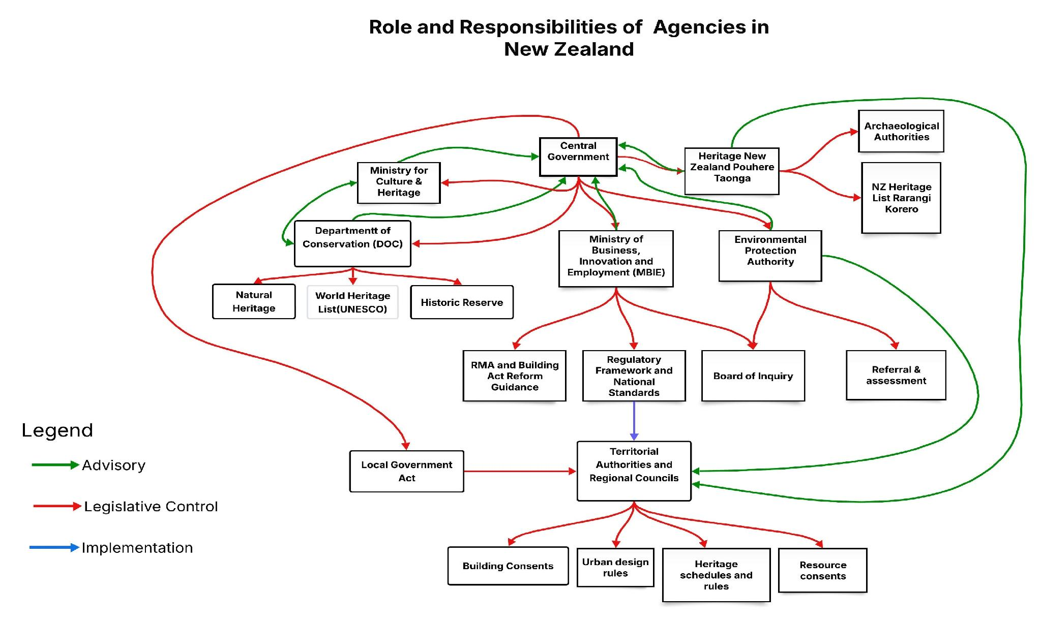

As illustrated in the diagram, New Zealand’s heritage protection framework is characterized by significant structural complexity compared to the international models examined. The visualization reveals a fragmented network where responsibility is distributed across seven distinct agencies, yet Heritage New Zealand Pouhere Taonga operates primarily through advisory channels rather than legislative control. This lack of central, binding authority indicates a clear opportunity for reform. By consolidating these disparate mandates into a more integrated planning system similar to the unified models in Ireland or New South Wales, New Zealand could eliminate existing coordination gaps and ensure more consistent national protection outcomes.

4. Recommendations for Further Research and Action
An evidence-based analysis of the United Kingdom, Ireland, and Australia provides a legally and administratively transferable context for New Zealand. While federal system (such as the Canada) offers interesting case studies. While researching countries like the USA could offer different perspectives, their federal structures and supreme constitutional property rights often create legal noise that does not apply to New Zealand. By focusing on Unitary or Quasi-Unitary systems will further ensures the research avoids the complexities of divergent constitutional frameworks and provides a pure comparison of policy tools. This will make resulting recommendations more practical for New Zealand policymakers to adopt. The international evidence gathered in this report is definitive: successful heritage protection requires a balance of independent judicial oversight and robust financial incentives. Consequently, future research should shift priority away from further international benchmarking and toward monitoring the domestic impacts of recent New Zealand reforms.
4.1 The Case for a National Heritage Monitoring System
New Zealand currently lacks a robust heritage monitoring system, whereas most of the comparator countries considered in this report track heritage outcomes systematically. Establishing a National Heritage Monitoring System would allow for the empirical measurement of MDRS impacts, an assessment of Fast-track legislation effects, and a comprehensive evaluation of RMA reform outcomes.
At present, heritage protection in New Zealand is being undermined by a lack of quantitative data. Without evidence-based research, qualitative recommendations from heritage advocates can appear less effective to policymakers. Future research must prioritize monitoring the real-world impacts of current legislation, both pre- and post-implementation, to provide actionable, evidence-based recommendations.
4.2 Public Education
To bridge the gap between legislation and public understanding, New Zealand could adopt Australia’s model of producing short, plain-language educational resources. For example, simple explanatory videos regarding Australia’s Environment Protection and Biodiversity Conservation Act (EPBC Act) have made complex legal frameworks significantly more accessible. Adopting similar resources in Aotearoa would empower property owners, developers, and local communities to better navigate the new planning and natural environment legislative landscape.

