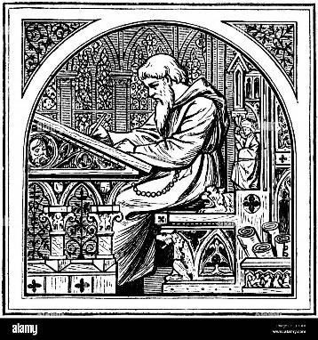 Notes from the Board

ICOMOS Aotearoa New Zealand
Te Mana O Nga Pouwhenua O Te Ao

October 2026

Kia ora ICOMOS whanau

ICOMOS ANZ AGM 2026
There were highs. There were lows. There were dramatic plot elements. Okay, no there wasn’t, but we’re grateful to the members who attended our short and sharp AGM on 7 October.
Our wonderful Chair, Stacy, gave her chair’s report as a powerpoint: I reproduce her slides here to present the work your board and organisation have undertaken in this past year.
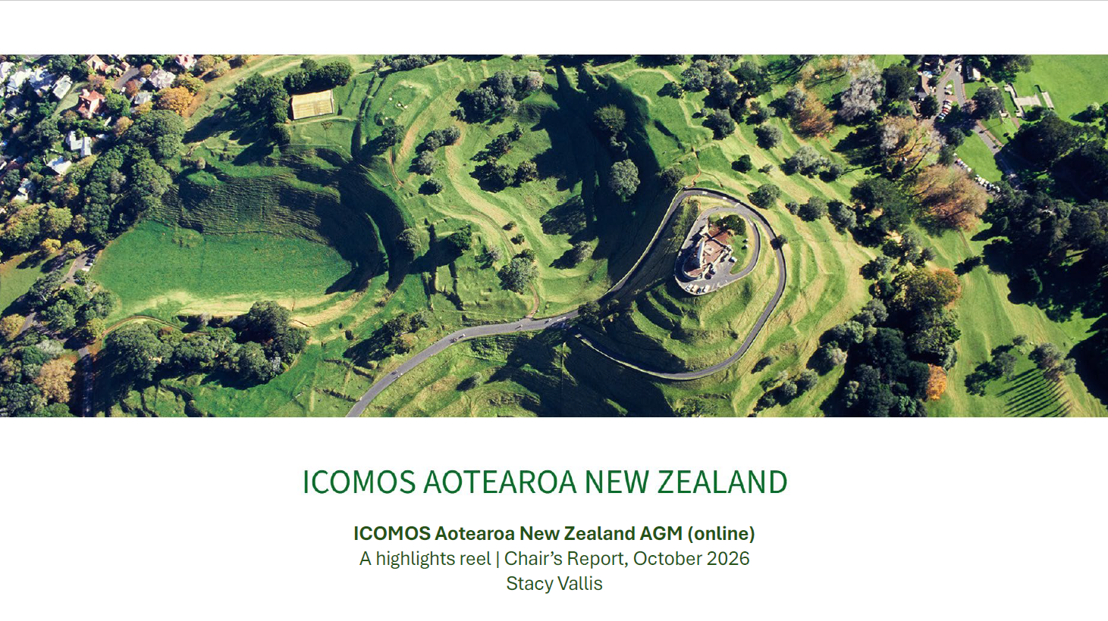
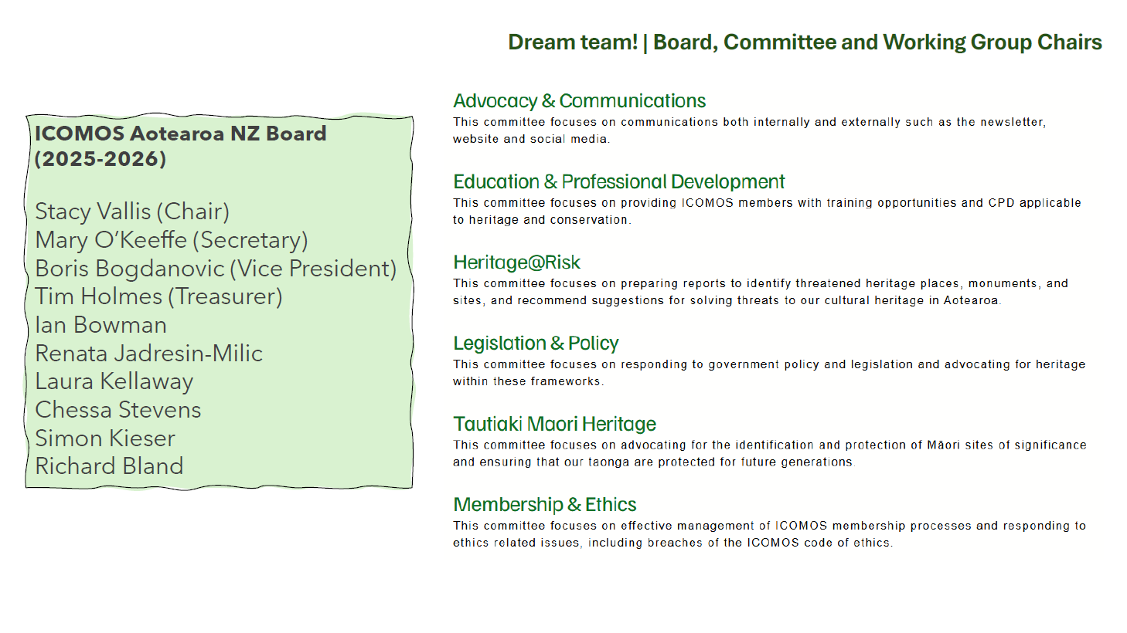
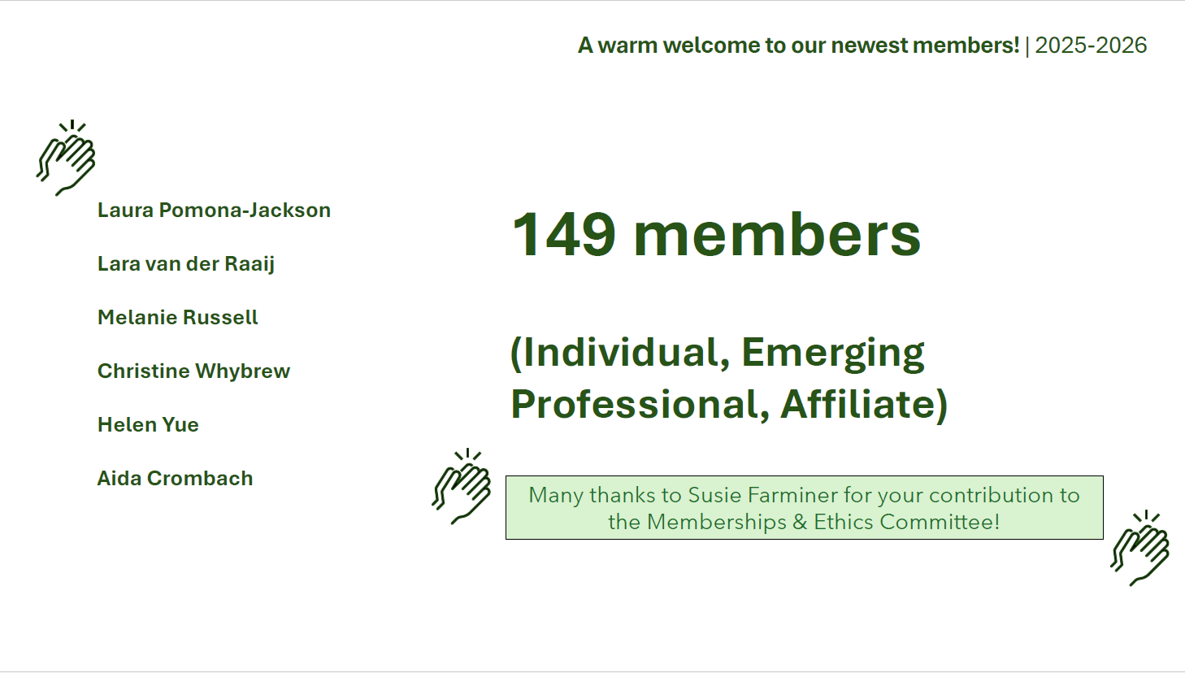
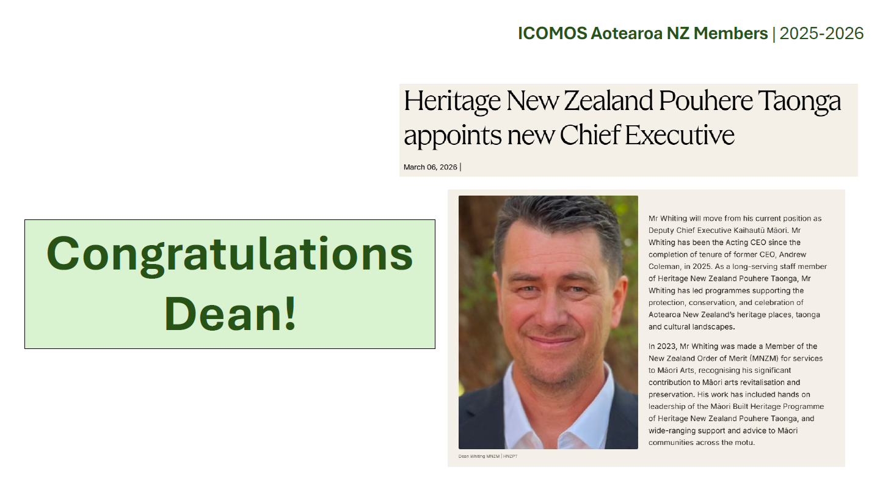
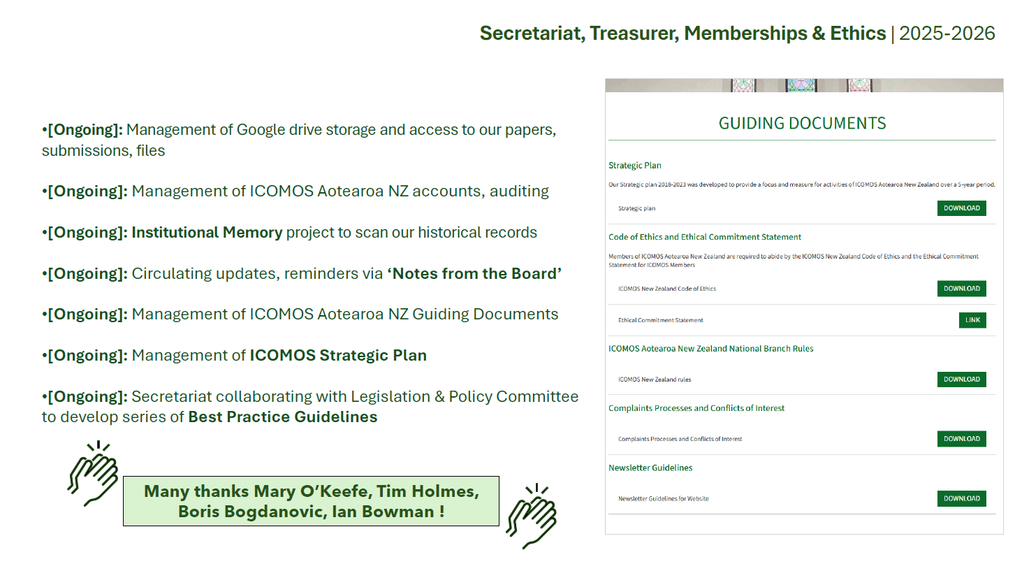
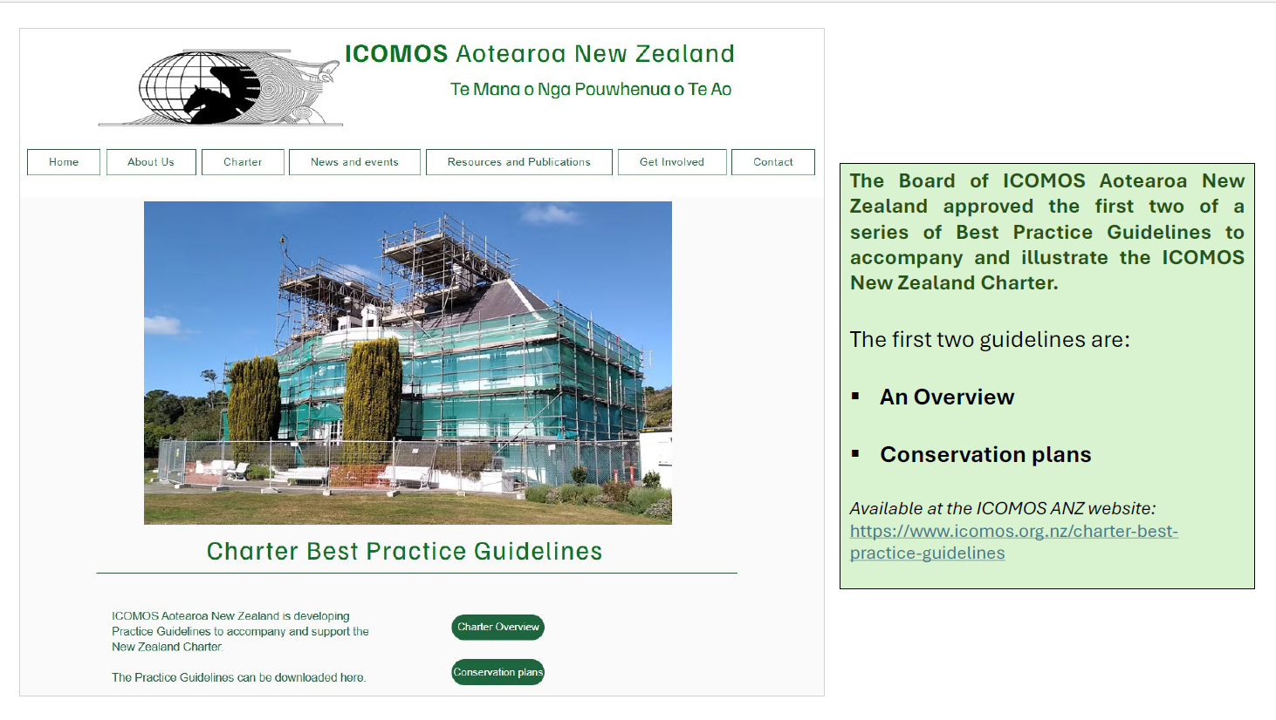
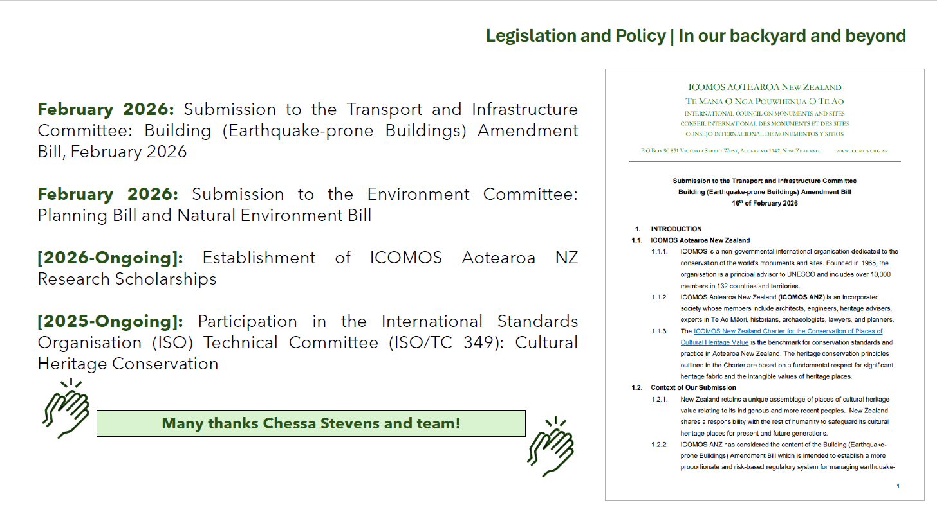
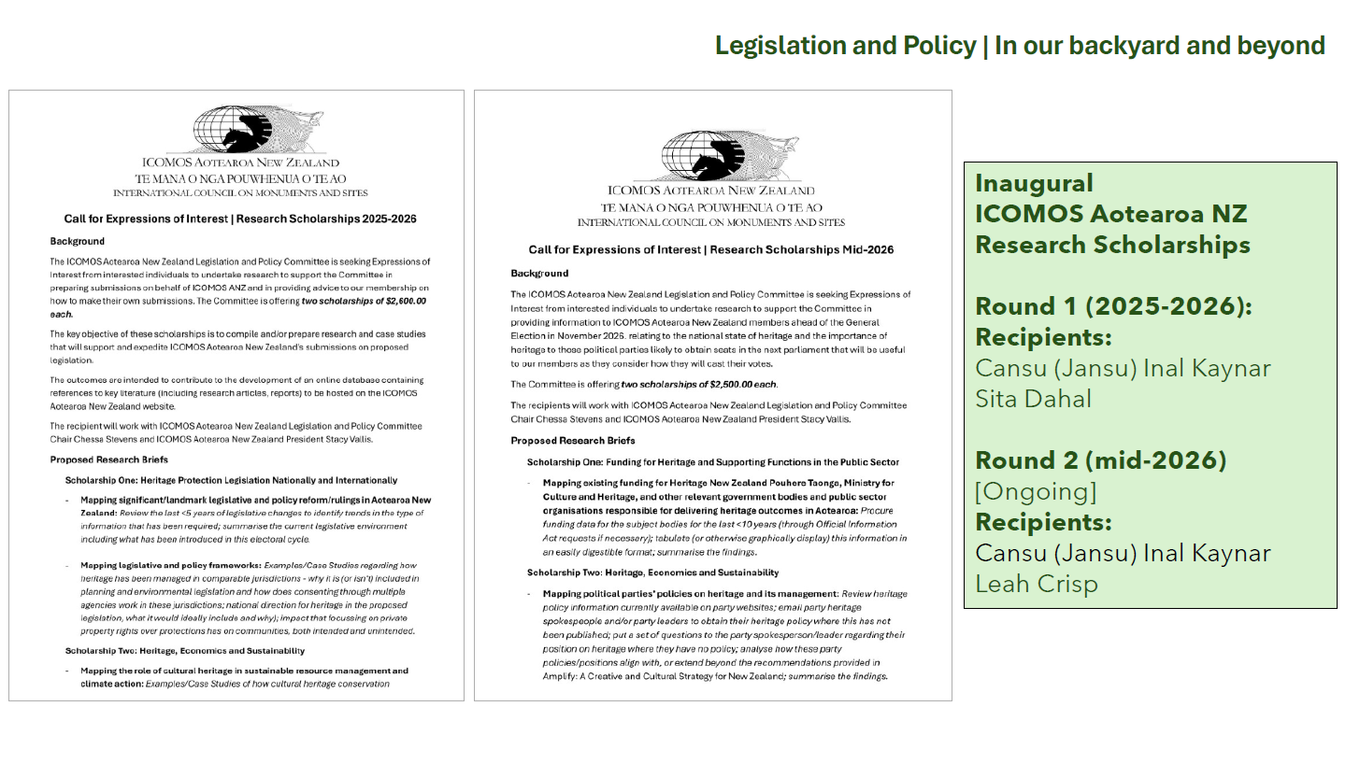
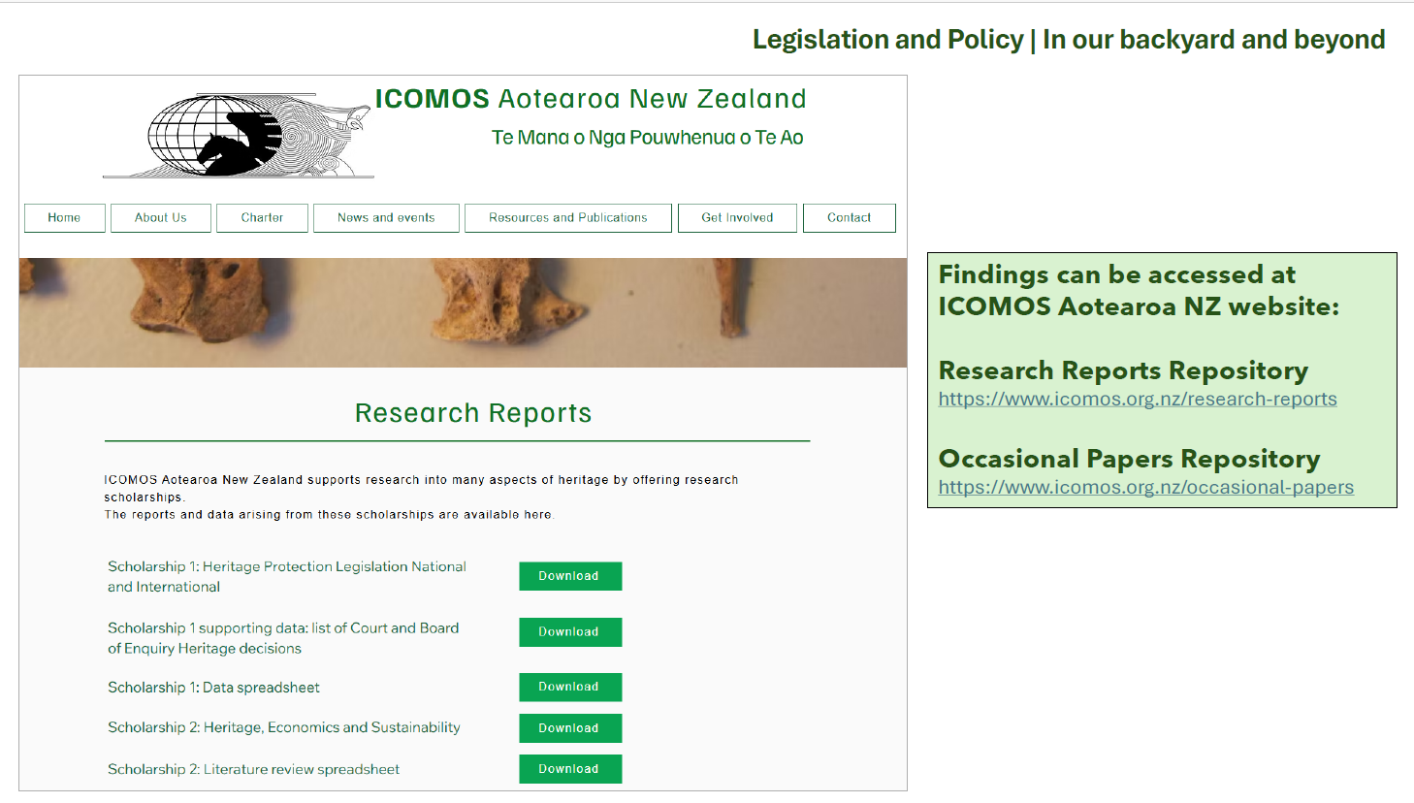
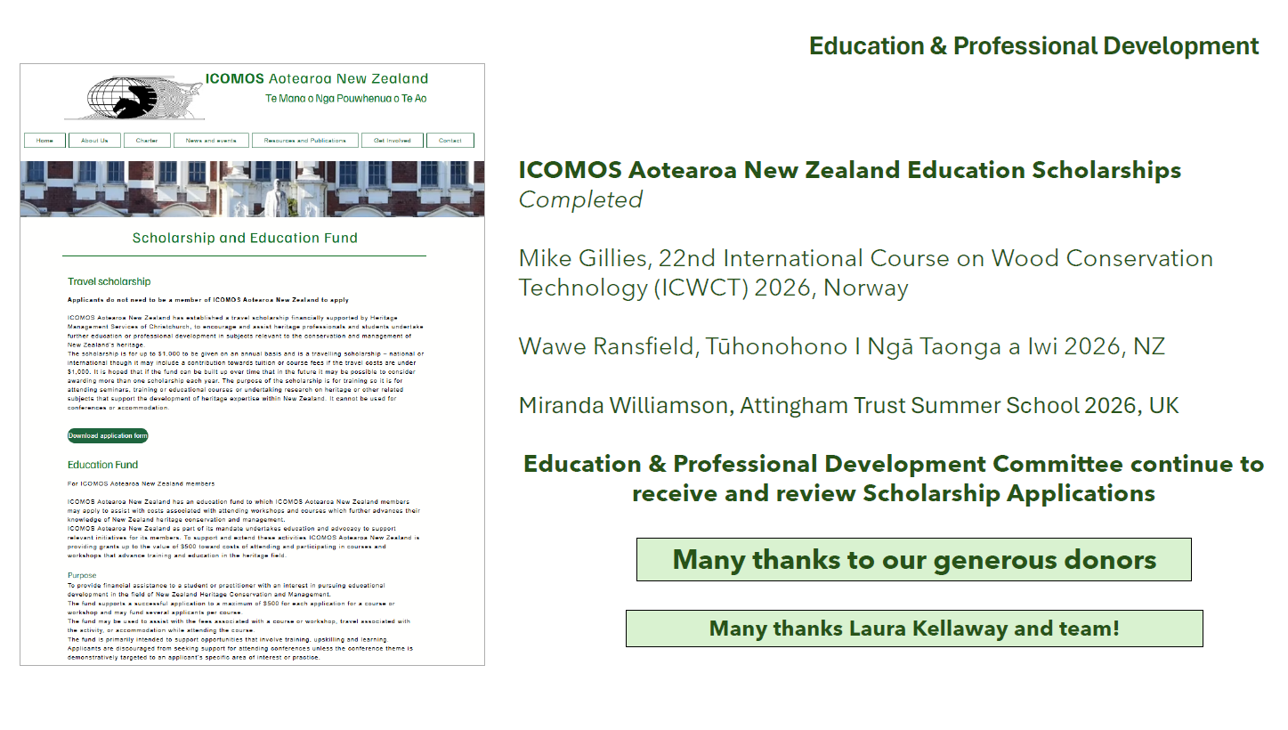
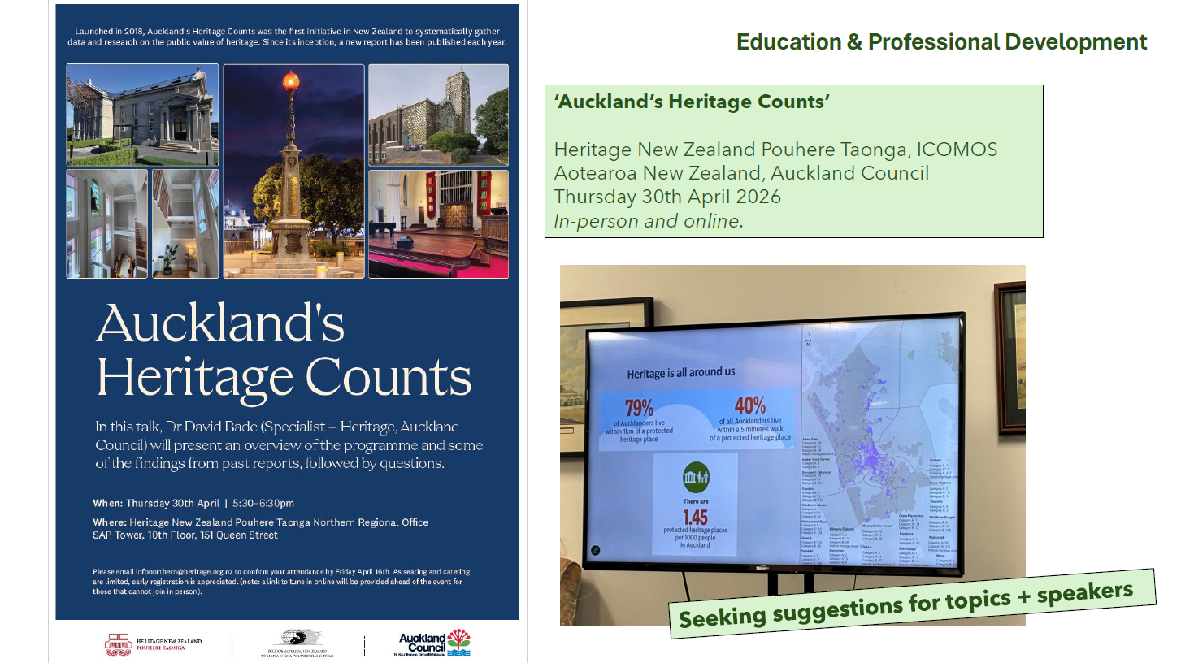
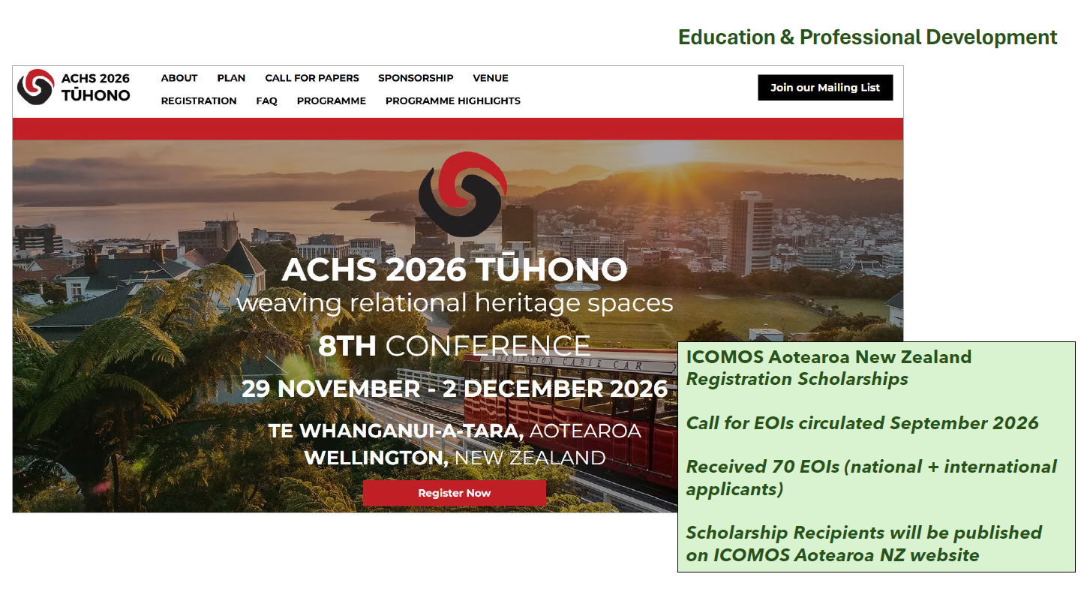
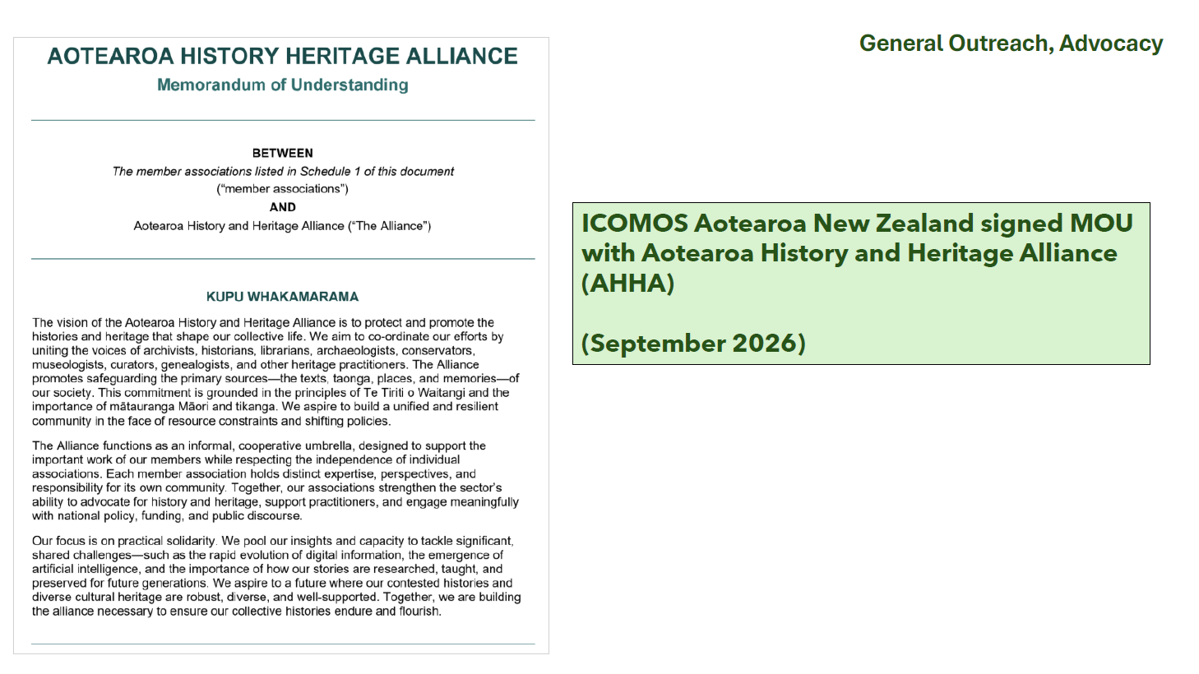
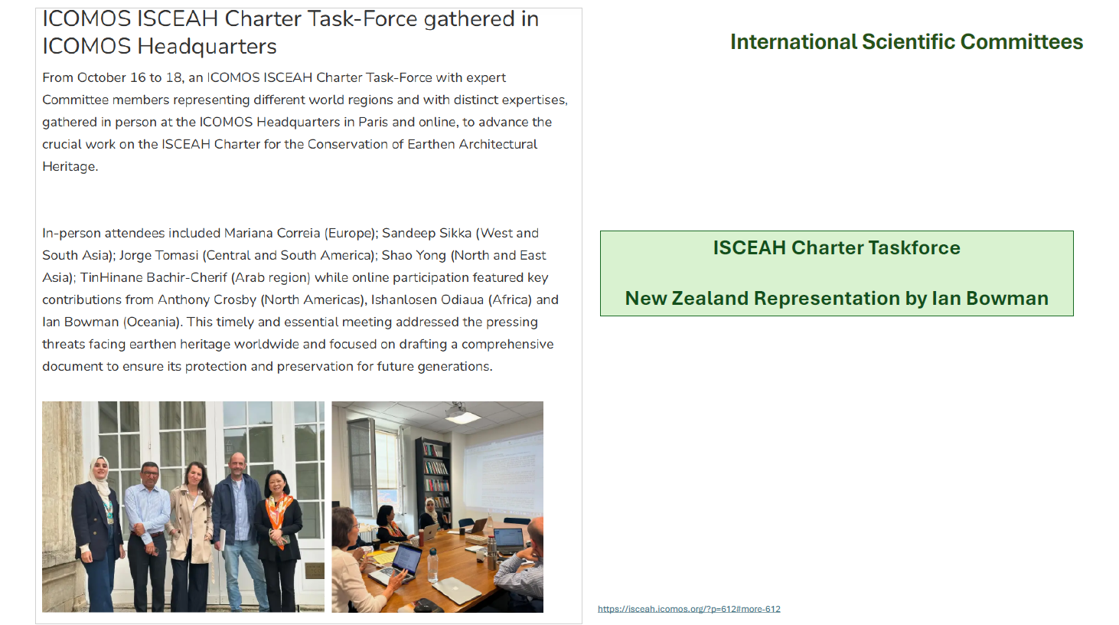
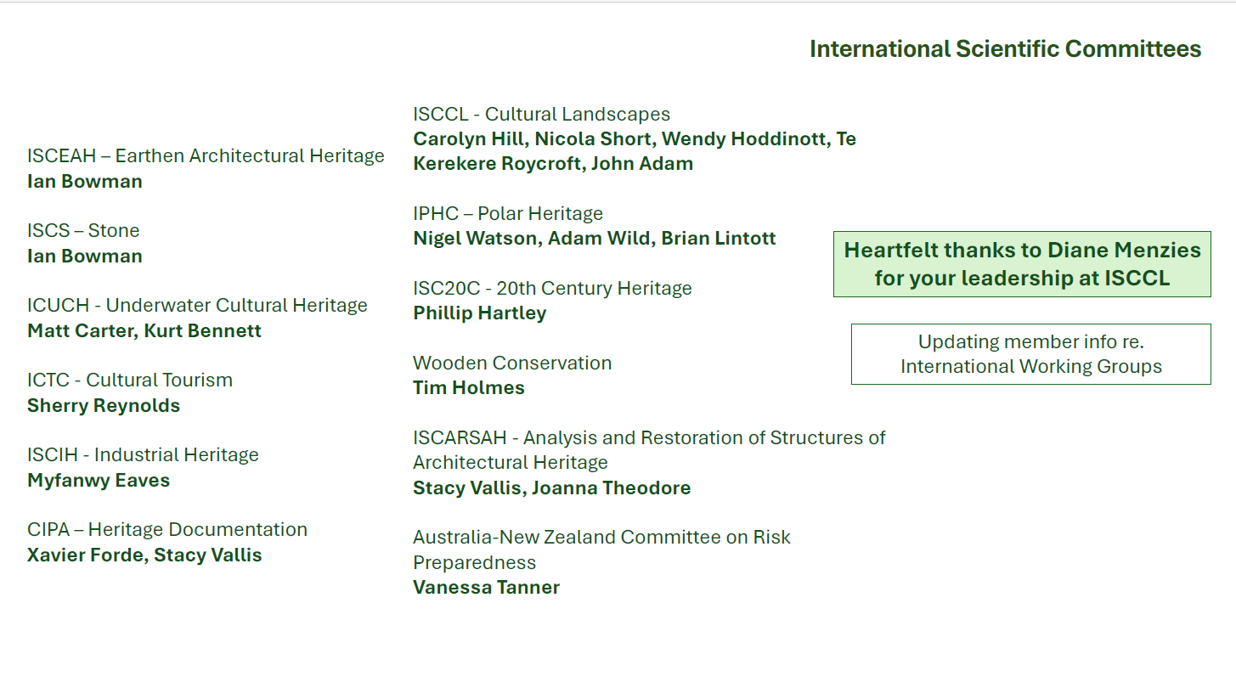
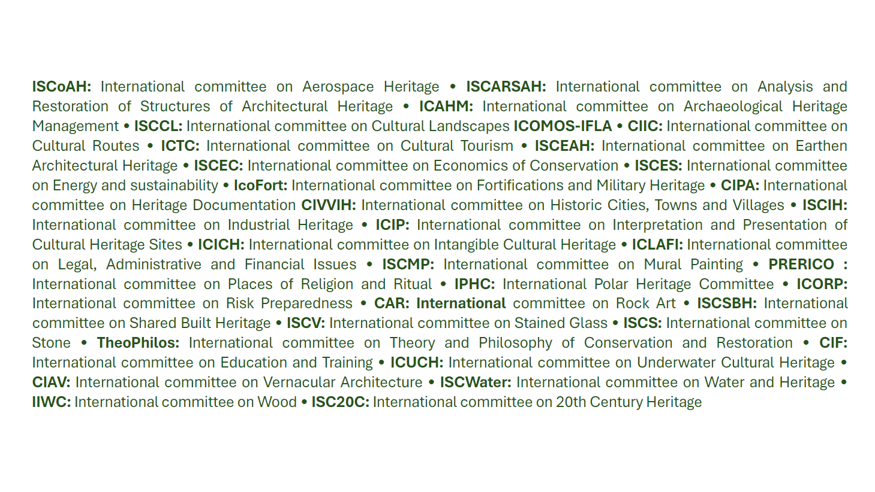
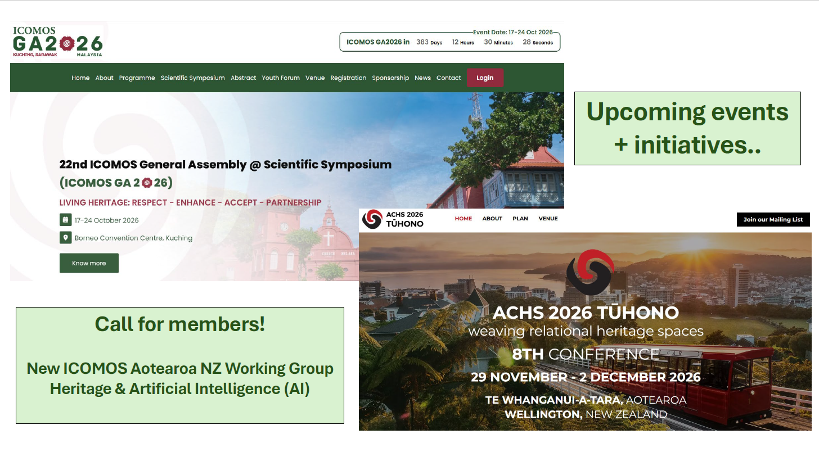
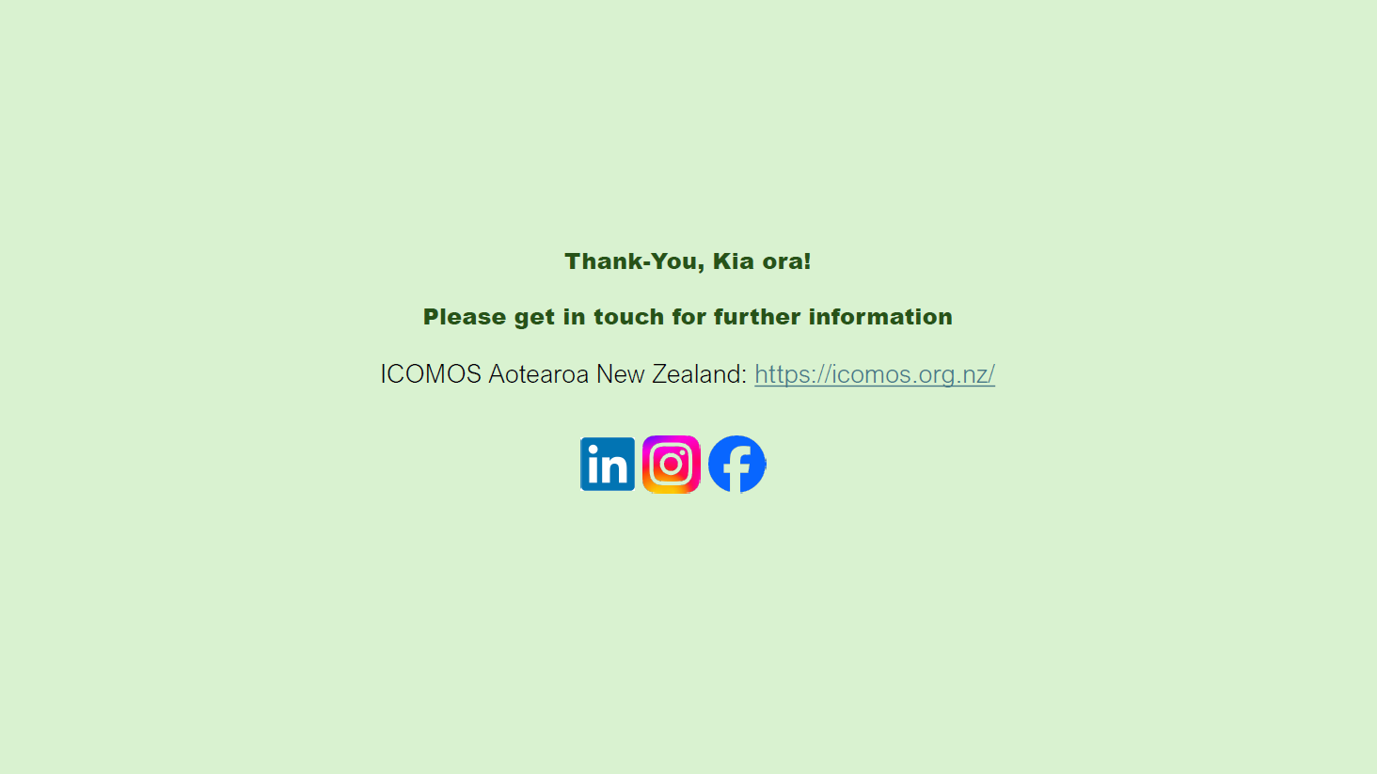

Meet your new board!
Your board for 2026-2027 is:
Stacy Vallis (chair)
Ian Bowman (deputy chair)
Carolyn Hill (treasurer)
Cansu Inal Kaynar (correspondence secretary)
Mary O’Keeffe (board secretary)
Chessa Stevens
Heike Lutz
Renata Jadresin Milic
Laura Kellaway
Tim Holmes
Simon Kieser

Vale Dinah Holman
We are deeply saddened to hear of the death of Dinah Holman on 21 September 2026. Dinah was a founding member of ICOMOS Aotearoa New Zealand. Dinah also served on the board of Historic Places Trust (now Heritage New Zealand Pouhere Taonga), and was very active in the Auckland heritage community.
Dinah was awarded the QSO (Companion of the Queen's Service Order) for Public Service to Heritage in 1987, and the New Zealand Planning Institute Distinguished Service Award in 1992.
Heritage NZ remembered how active Dinah was in Auckland in the 1980s-90s tear ‘em down era of development, and noted she was responsible for several heritage orders.

NZ World Heritage Tentative List
Dept of Conservation undertook a review of our World Heritage Tentative List earlier this year (ICOMOS ANZ members Ian Bowman and Mary O’Keeffe were Observers to the review, and provided guidance and commentary).
The Minister has approved the revised list, and DoC released the list on 7 October 2026.
The list is:
Waitangi Treaty Grounds/Te Pitowhenua and Te Tii Marae – the site where New Zealand’s founding document, Te Tiriti o Waitangi / The Treaty of Waitangi was first debated and signed in 1840.
Mataatua Wharenui – Te Mānuka Tūtahi, Whakatāne – a monumental carved Māori meeting house (wharenui) in Whakatāne (Ngāti Awa).
Te Whare Waiutuutu Kate Sheppard House, Christchurch – the home from which Kate Sheppard led the campaign that helped make New Zealand the first country in the world to grant women the right to vote.
Parihaka Papakāinga– a historic Māori settlement at the base of Taranaki Maunga and a renowned centre of nonviolent resistance to land confiscation under the leadership of Tohu Kākahi and Te Whiti o Rongomai.
Te Kauwhanganui Māori Parliament Building, Monument, and Taonga Collection, Morrinsville – preserves a rare Indigenous parliamentary system and comprises Te Kauwhanganui building, King Mahuta monument, and a surviving archive of 20,000+ documents largely in te reo Māori.
Te Hauturu o Toi/Little Barrier Island – one of the world’s most intact temperate island ecosystems and a powerful example of conservation grounded in both science and Indigenous stewardship.
Tch Tatatei Awanui/Scenic Reserve Wharekauri coastal strip, Chatham Islands – a significant Moriori cultural landscape containing settlement sites, burials and the archaeological remains of the voyaging waka Rangihoua.
Ngā Tapuwae o Mataaho, Auckland Volcanic Fields – a cultural and volcanic landscape shaped by the Auckland volcanic field and its deep associations with Māori history and traditions.
Kermadec Islands and Marine Reserve – located about 1,000 km northeast of New Zealand, these are among the most strictly protected reserves in New Zealand.

DoC’s press release is at https://www.doc.govt.nz/news/media-releases/2026-media-releases/potential-world-heritage-sites-announced/

ICOMOS 2026 General Assembly
The 22nd ICOMOS General Assembly (GA) and the Scientific Symposium is about to take place in Kuching, Malaysia, from 17 to 24 October 2026, organized by ICOMOS Malaysia.
www.icomosga2026.org.my/en/home
A small NZ contingent are attending.

Farewell to Boris
We are sad that Board member Boris Bogdanovich has stood down from the Board in recent months. But Boris has resigned for the best of reasons - he has returned to London to undertake his Masters degree at the Bartlett (Bartlett Faculty of the Built Environment, University of London; https://www.ucl.ac.uk/bartlett if you want to get those envy juices flowing)

Scholarships
ICOMOS ANZ has been offering scholarships for research projects, and continues to offer travel scholarships.
As a result we have received, and continue to receive, wonderful reports on the experience people have had and the knowledge they have gained.
All of these reports are being uploaded to our website, so members can enjoy them and also access the information they contain.
Recent reports received:
Travel Scholarships:
- Mike Gillies: 22nd International Course on Wood Conservation Technology (ICWCT)
- Miranda Williamson :Reflection – Attingham Trust Summer School 2026
Research Scholarships
- Cansu Inal Kaynar is currently researching “Mapping existing funding for HNZPT, MCH, and other relevant government bodies responsible for delivering heritage outcomes in Aotearoa”
- Leah Crisp is currently researching “Heritage, Economics and Sustainability - Mapping political parties’ policies on heritage and its management”

Digital membership cards
ICOMOS membership cards are posted to us from Paris, on a somewhat ad hoc basis ( we don’t control the timing.
But did you know you can make yourself a digital card?
- Go to the ICOMOS website https://www.icomos.org/
- log in to the member’s portal, by clicking on the wee “head” icon at the top of the screen:
- you’ll log in using the email address you used when you joined ICOMOS, and the password you’ve chosen (there’s a”forgot your password” link!)
- then choose French or English by clicking on the FR or EN at the top of the toolbar
- then go to “my profile" by clicking the down arrow beside the Head icon at the top of the screen
- “E-card” will be an option in the tool bar you can see - you’ll need to upload a photograph
- E cards can be downloaded as PDFs or PNGs

We need a newsletter editor!
Do you enjoy creative writing? Want to help the heritage sector? Do we have the role for you!
ICOMOS ANZ produces a digital newsletter four times a year. The editor’s role is as much a corralling role – various people will offer content, and the editor needs to nag them into delivery. The editor also lays out the newsletter for distribution. A template and full instructions provided. With the added warm glow of helping your organisation (bask in that righteous warmth).
Give Mary a shout at secretariat@icomos.org.nz

Mary O’Keeffe
Board Secretary
secretariat@icomos.org.nz

