ICOMOS Aotearoa New Zealand

BEST PRACTICE GUIDELINES:
Charter for the Conservation of Places of Cultural Heritage Value
Conservation Plans

What is the Purpose of this Guideline?
This guideline provides a brief interpretation of the purpose, development, and use of Conservation Plans.

What is a Conservation Plan?
In simple terms, a conservation plan is a document that establishes the heritage significance of a place and provides heritage policies for its conservation and for future use. The Charter defines a conservation plan as:
an objective report which documents the history, fabric, and cultural heritage value of a place, assesses its cultural heritage significance, describes the condition of the place, outlines conservation policies for managing the place, and makes recommendations for the conservation of the place.
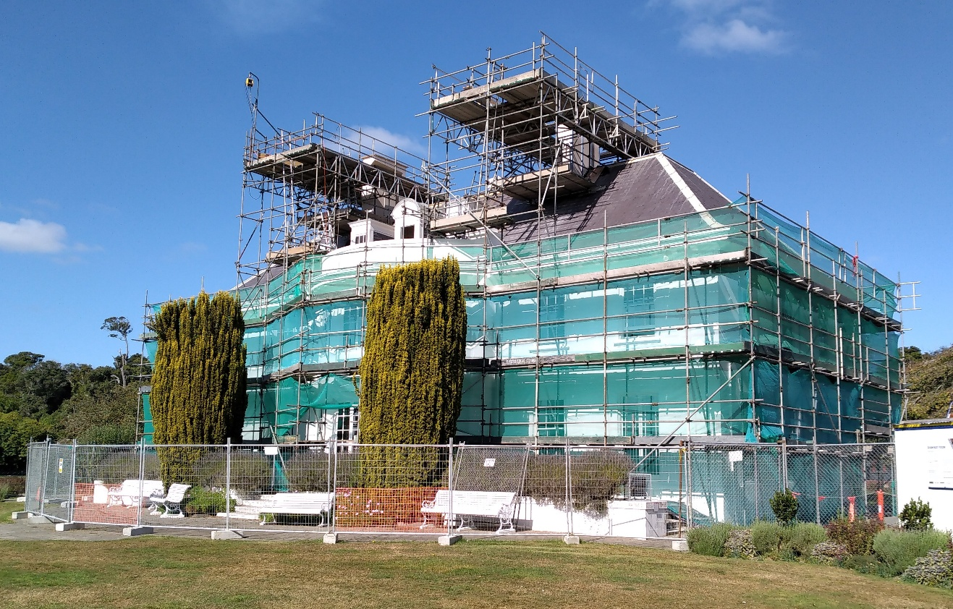
Anderson House, Invercargill, during restoration works, 2021
Photo: Chessa Stevens
Different guiding documents
As well as a conservation plan, several types of guiding documents may be used to guide work on heritage places. These include:
- Existing Conservation Plans
- Heritage significance assessments
- Heritage based condition assessments
- Long term maintenance plans
- Temporary protection plans
- Heritage effects assessments
- Heritage inventories
- Standing building, architectural, engineering, and structure records
- Archaeological Surveys, Assessments & Authorities
- Materials Research and Analysis, and technical guides
- Schedule of Works
- Works Specifications
Some parts of these documents may also be used in a conservation plan

Parts of a Conservation Plan
A Conservation Plan is typically split into two stages:
Stage 1: Understanding the Place
Stage 2: Conservation Policies
Stage 1: involves gathering information, from a variety of sources including documents and drawings, examining fabric as well as speaking to key stakeholders. This stage aims to establish everything that can be reasonably known about a place that could be relevant for future decision making, and should therefore include the condition of a place. Based on this information the cultural heritage values can be understood, and, in turn, the significance of a place can be established.
The level of research undertaken should be fit for purpose – in some cases an exhaustive research stage may not be necessary. It may require different specialists and should be integrated in approach to the layers of values of the place.
Stage 2: involves developing policies and determining how and when they will be implemented. These policies respond to the information gathered in stage 1, therefore the stages need to be carried out consecutively. During stage 2 the key objectives of various stakeholders should also be set out as these will have an impact on the policies. Objectives may, for example, include seismic strengthening, or a change of use. Policies will recommend an approach based on the understanding of the place established in stage 1, and on the key conservation based objectives.
A conservation plan should be updated regularly. Triggers for an update may include changes to stakeholder objectives, changes to state of fabric or the place, new information may become available, changes to legislation, changes in use.
The principles set out in the ICOMOS New Zealand Charter for the Conservation of Places of Cultural Heritage Value (2010) should underpin the conservation plan.

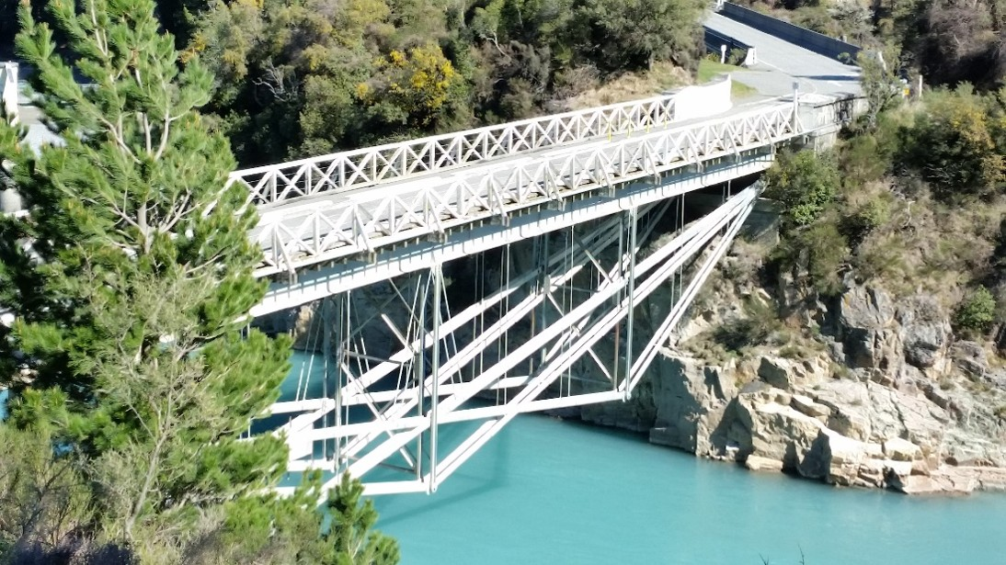
Rakaia Gorge No. 1 Bridge, following restoration, 2020
Photo: Chessa Stevens

When and why is a Conservation Plan Required?
The charter states:
All conservation work should be based on a conservation plan which identifies the cultural heritage value and cultural heritage significance of the place, the conservation policies, and the extent of the recommended works. (article 4)
It can be used for any type of place, including:
…areas, cultural landscapes and features, buildings and structures, gardens, archaeological sites, traditional sites, monuments, and sacred places…
Ideally, every conservation project should be guided by a conservation plan. It should be concise and easy to use.
A conservation plan is a benchmark: for knowledge and understanding of the place, for the heritage significance of the place, for ongoing protection, for being work undertaken, and for work that may be needed, including under emergency situations or events.
A conservation plan may be commissioned when changes to a place are proposed. However, gaining understanding of a place and setting policies for its future management can be done at any stage.

How big or small should a Conservation Plan be?
Above all a conservation plan should be fit for purpose. Its length will vary according to the complexity of the heritage place it is being written for. More is not necessarily better – a short concise plan will often be sufficient.

Who uses a Conservation Plan?
A Conservation Plan should be useful and useable for many different people:
… including owners, guardians, managers, developers, planners, architects, engineers, craftspeople and those in the construction trades, heritage practitioners and advisors, and local and central government authorities.
… communities, organisations, and individuals involved with the conservation and management of cultural heritage places.
Typically, a conservation plan will be written by a heritage professional, and may involve several contributors such as archaeologists, landscape architects, historians and/or architects. This work should always be done in consultation with those who are connected to the place and may include a variety of stakeholders as well as wider community groups.

Funding for a Conservation Plan
For community heritage Lottery Environment and Heritage Funding may be available. There may also be local funds as a conservation plan helps with long term understanding as well as for ongoing staged repairs.
https://www.communitymatters.govt.nz/lottery-environment-and-heritage

References:
ICOMOS New Zealand. ICOMOS New Zealand Charter for the Conservation of Places of Cultural Heritage Value. Revised 2010.
James Semple Kerr. The Conservation Plan. 7th ed. Sydney: National Trust of Australia, 2013.
www.heritage.org.nz/resources/conservation-plans

Approved by the Board of ICOMOS Aotearoa New Zealand, June 2026

