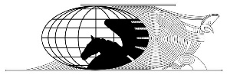ICOMOS Aotearoa New Zealand

BEST PRACTICE GUIDELINES:
Charter for the Conservation of Places of Cultural Heritage Value
An Overview

What is the Purpose of this Guideline?
This guideline provides a brief interpretation of the use and application of the ICOMOS New Zealand Charter for the Conservation of Places of Cultural Heritage Value 2010 (The Charter). The Charter is available in Te Reo Māori: Te Tūtohinga ICOMOS O Aotearoa
2010.

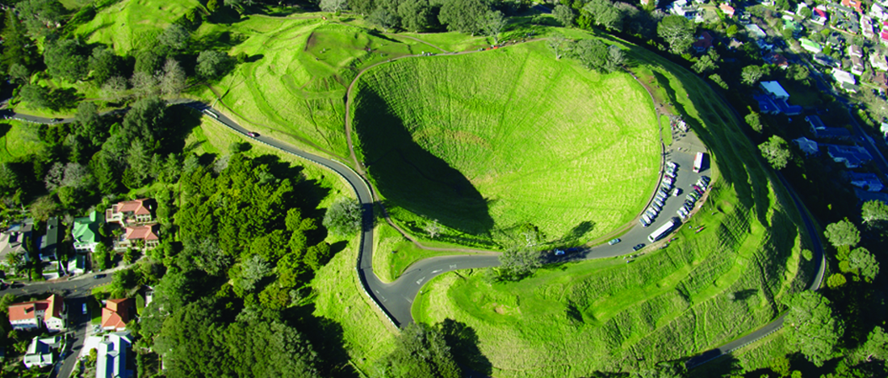
Maungawhau- Mount Eden, Auckland
Photo: Kevin Jones

What is The Charter for?
The Charter guides conservation and forms a recognised benchmark for conservation.

It sets out key principles (articles 1-13), as well as processes and practices (articles 14 – 24) that apply to conservation.

The purpose of conservation is to care for places of cultural heritage value (article 1). Conservation is defined in The Charter as:

… all the processes of understanding and caring for a place so as to safeguard its cultural heritage value. Conservation is based on respect for the existing fabric, associations, meanings, and use of the place. It requires a cautious approach of doing as much work as necessary but as little as possible, and retaining authenticity and integrity, to ensure that the place and its values are passed on to future generations.

Values may be tangible or intangible. The Charter sets out how to understand and determine cultural heritage value and significance (article 2).

A unique conservation principle in the New Zealand Charter is that of caring for indigenous heritage in line with the Treaty of Waitangi (article 3).

Conservation processes and practices are explained, such as the criteria for conservation plans (article 14) as well as guidance about how to undertake a conservation project (article15). Degrees of intervention – preservation, restoration, reconstruction and adaptation – that may be necessary are also explained (article 17).

Definitions of key terms are included at the end of The Charter.

Who is The Charter for?
It is a statement of professional principles for members of ICOMOS Aotearoa New Zealand. But it is also intended for use by everyone:

… including owners, guardians, managers, developers, planners, architects, engineers, craftspeople and those in the construction trades, heritage practitioners and advisors, and local and central government authorities.

It offers guidance for communities, organisations, and individuals involved with the conservation and management of cultural heritage places

Heritage New Zealand Pouhere Taonga, the Ministry of Culture and Heritage and the Department of Conservation use The Charter to guide their conservation work. The Charter has also been adopted as heritage policy by a number of district councils and is used by them as a standard reference document.

The Charter guides work for ALL types of places:

New Zealand retains a unique assemblage of places of cultural heritage value relating to its indigenous and more recent peoples. These areas, cultural landscapes and features, buildings and structures, gardens, archaeological sites, traditional sites, monuments, and sacred places are treasures of distinctive value that have accrued meanings over time.

Many of the principles, processes, and practices are primarily suited to built places, but the overall principles apply to all heritage places.

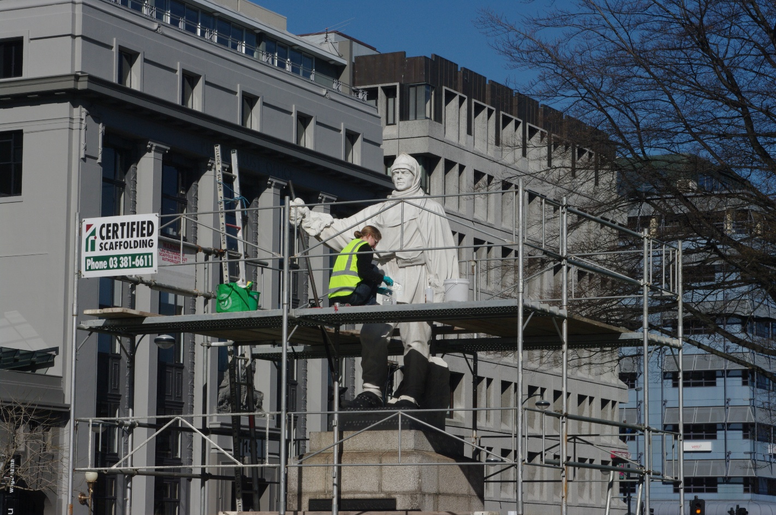
Conservation of Robert Falcon Scott statue, Christchurch
Photo: Kevin Jones

How do I interpret it?
A key part of understanding and working with The Charter requires that:

Each article of this charter must be read in the light of all the others.

Users of The Charter cannot, and should not, “cherry pick” certain strategies or processes that suit their objectives. Neither should they selectively ignore those that do not suit their objectives.

References:
ICOMOS New Zealand. ICOMOS New Zealand Charter for the Conservation of Places of Cultural Heritage Value. Revised 2010. Auckland: ICOMOS New Zealand, 2010.

Approved by the Board of ICOMOS Aotearoa New Zealand, June 2026

